# Descriptive and Inferential Statistics for Strategic Business Decision-Making

# 1. Introduction

## Background

Exploration of business intelligence is important in today’s competitive business environment in which the competition is high and firms need to make sound decisions. Statistics is very central to this decision-making process by offering the required analytical techniques and methods to be used in analyzing and making sense of data. Basic features of the data are described in the descriptive statistics where average characteristics of data are expressed with the help of mean, median and standard deviation. Such statistics allow the existence of business trends and detecting any abnormalities in the state of affairs.

## Objective

The main goal of this assignment is to carry out a statistical analysis of air quality data and draw out recommendations for the use of business strategies. Descriptive and inferential, statistics, thus, will be used in the analysis process in order to reveal patterns and trends in air quality data assess the effects that it might have on the well-being of the population or functionality of organizations and provide recommendations to the changes observed. Altogether this analysis will enhance the understanding of how the quality of air impacts business and areas of possibilities of efficiency improvement or policy adjustments.

## Scope

This report will be sectioned as follows in order to present an analysis of the air quality data. To start with, the report will elaborate on the process of data cleaning, which is deemed critical for the analysis. After this, attempts will be made to use descriptive statistics as a means to present and display the data collected, with the aim of determining its nature and location of the central tendencies. With the use of inferential statistics, predictions and hypotheses testing about the existing air quality will at last be conducted. Last of all, there will be information on normalization techniques to be used for data preparation and further analysis.

# Data Cleaning and Preparation

## Overview of the Dataset

The source of data for this report is the ‘airquality’ file. csv file with a number of variables characterizing ratings of air quality measurements. . Some of these variables are:

1. Ozone
2. Solar.R (Solar radiation)
3. Wind
4. Temperature(Temperature)
5. Month
6. Days

The data is rather of the reflective sort, more specifically continuous, i. e., numerical, variables – Ozone, Wind, Temp, are all environmental measurements. The variables ‘Month’ and ‘Day’ are categorical variables representing the time at which those observations were made.

## Step 1: Loading the Dataset

The first process of data cleaning and preparation starts with the loading of the air quality data set into R environment can be achieved by using the read. csv () function to read the dataset needed in the program from a CSV file.

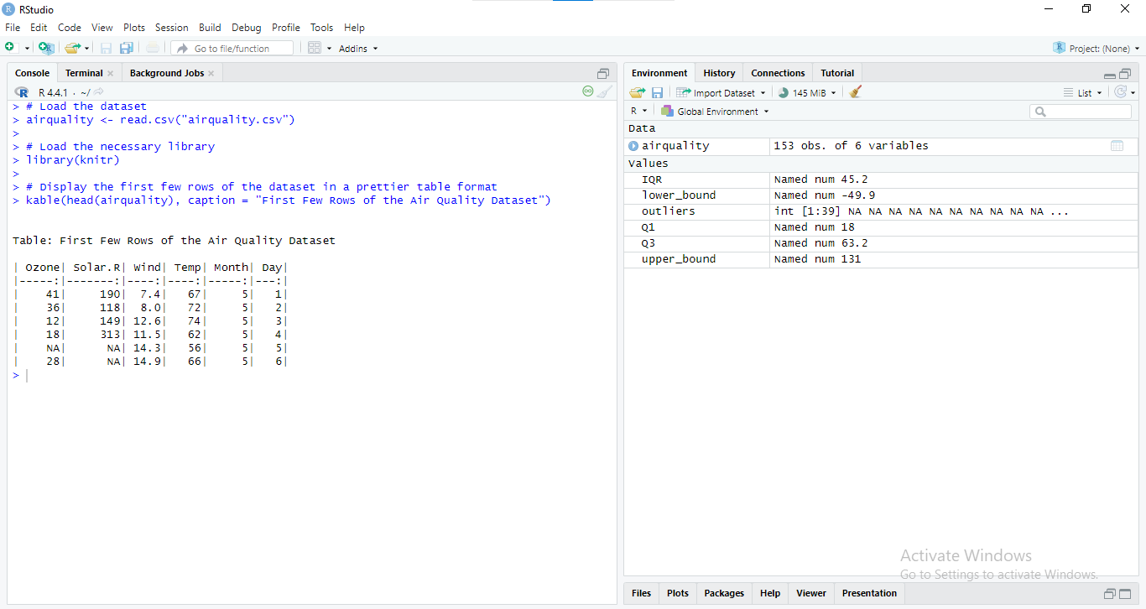

Figure : RStudio interface demonstrating data loading and exploration

## Step 2: Summarizing the Dataset

Once the dataset is loaded, it is useful to get a brief description of the over data, and it can reveal, for instance, whether missing values are present. In R the summary () function offers a statistical resume of each variable.

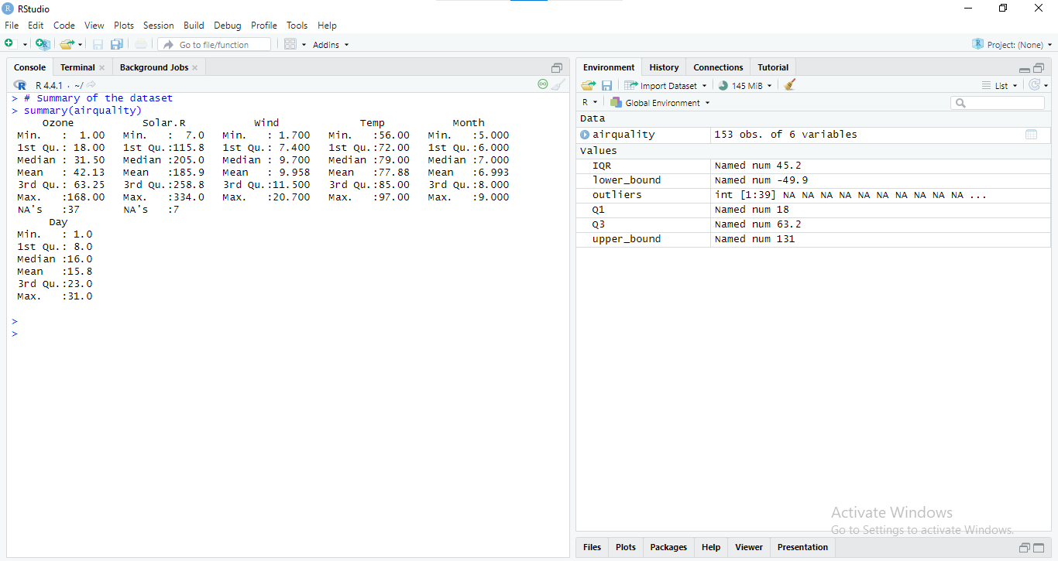

Figure : RStudio console output for the airquality dataset summary

The results generated in output are minimal, first quartile, median, mean, third quartile, maximal values of distributions, and the number of NA’s for each variable.

## Step 3: Identifying Missing Values

Feature values missing in the dataset can pose a problem in the analysis to be made, and thus they need to be spotted and dealt with. The **is. Na()** function can also be used in order to obtain the total number of missing values in each variable.

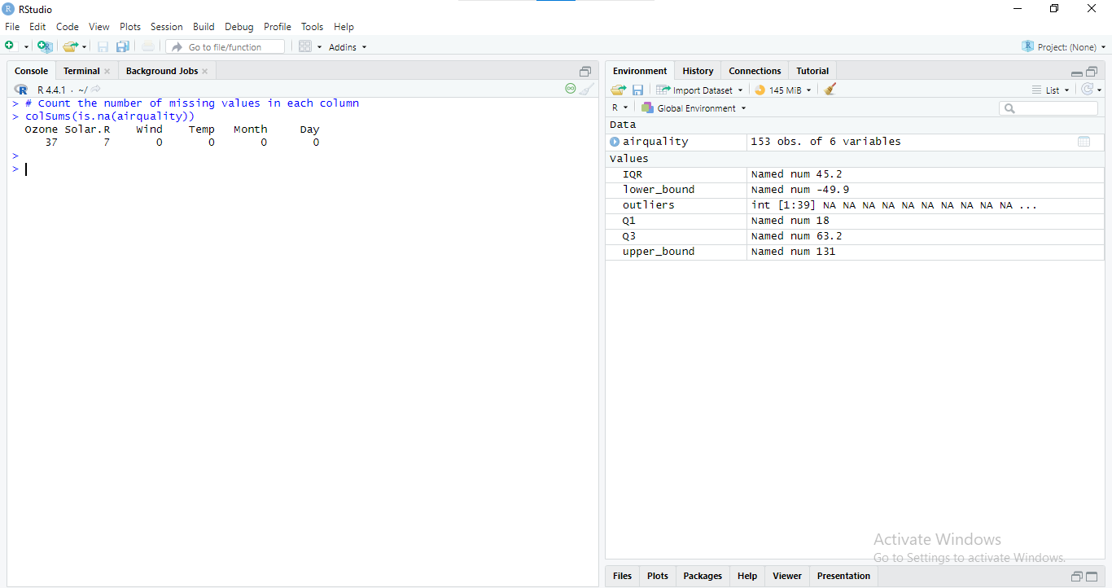

Figure : RStudio output for missing value count in the airquality dataset

This command offers the number of missing values of every column and hence can be used to assess the level of missing data in the given dataset.

## ****Step 4: Handling Missing Values****

Option that can be used to manage missing data is called imputation whereby missing data is substituted with other figures for example average. In this dataset, missing values in the Ozone variable can be imputed with the mean of the values which were actually recorded.

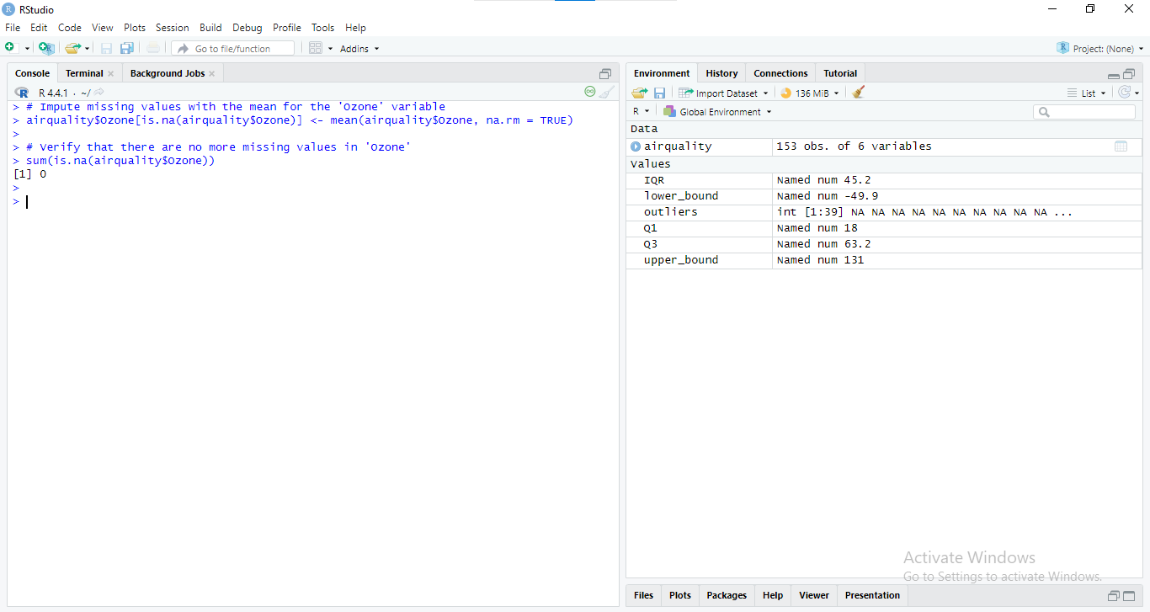

Figure : RStudio console output showing missing value imputation

This code provides with the complete status of the variable Ozone by replacing the NA values with the average of the actual values of Ozone.

## Step 5: Identifying Outliers

Extreme values have a significant influence on business statistics therefore it is crucial to deal with them. Outliers can be easily identified by a well-known method known as the interquartile range or the IQR method.

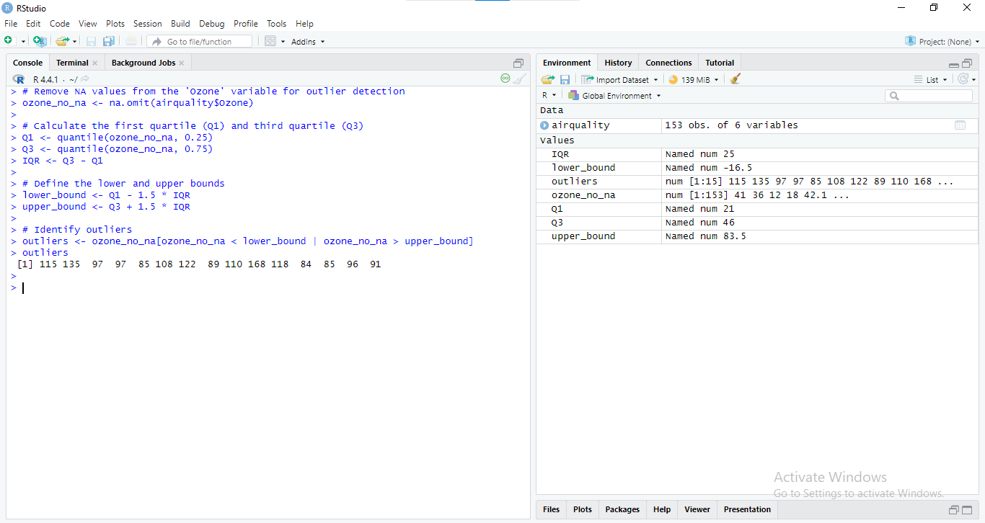

Figure : RStudio console output showing the calculation of interquartile range (IQR) and identification of outliers in the 'Ozone' variable.

This code computes the IQR for the variable ‘Ozone’; what are considered as an outlier; and which values for this variable are outliers.

## Step 6: Data Transformation

Data transformation is at times done so as to enable the data to be in the right format for analysis. Current transformations like scaling and log transformations assist in normalizing the data and lessening on the skewness.

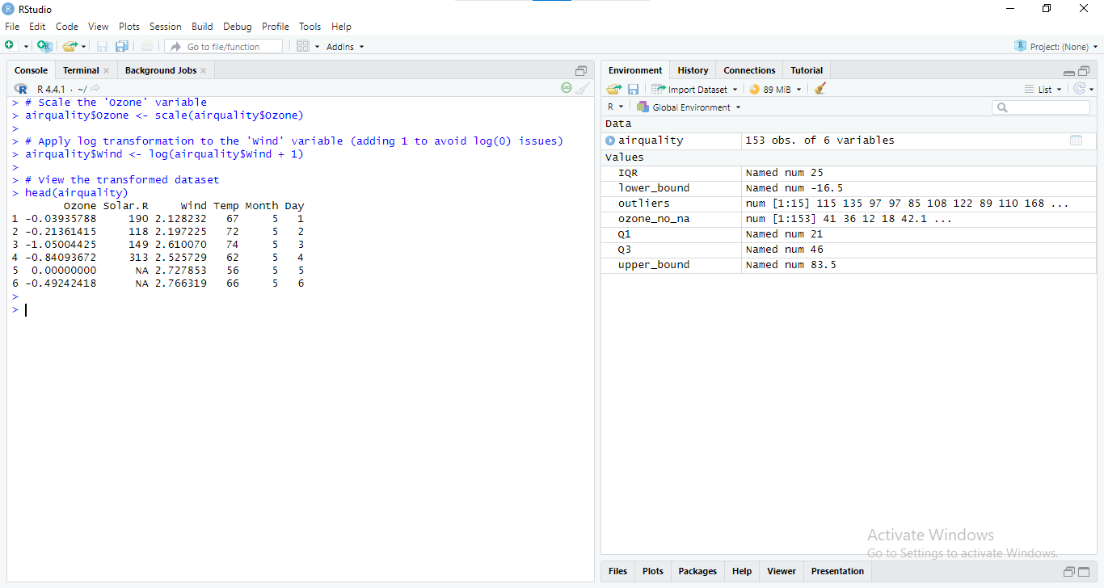

Figure : Data preprocessing steps in RStudio: scaling and log transformation for improved analysis

In this case, the values of the Ozone variable are standardized while the values of the Wind variable are log-transformed in-order to correct skewness and variations in variance.

# 5. Descriptive Statistics

The descriptive statistics give overall information of the dataset wherein making a general exploration of the data set that is an overview of its tendencies, dispersion, and distribution. In this section, the main areas discussed involve means, standard deviations, skewness, and kurtosis as well as lectures on correlation.

## Summary Statistics

Descriptive statistics are very important in data analysis as they provide a base of the features of the dataset. Some of central tendency measures include mean, median and mode while measures of dispersion are range, variance and standard deviation.

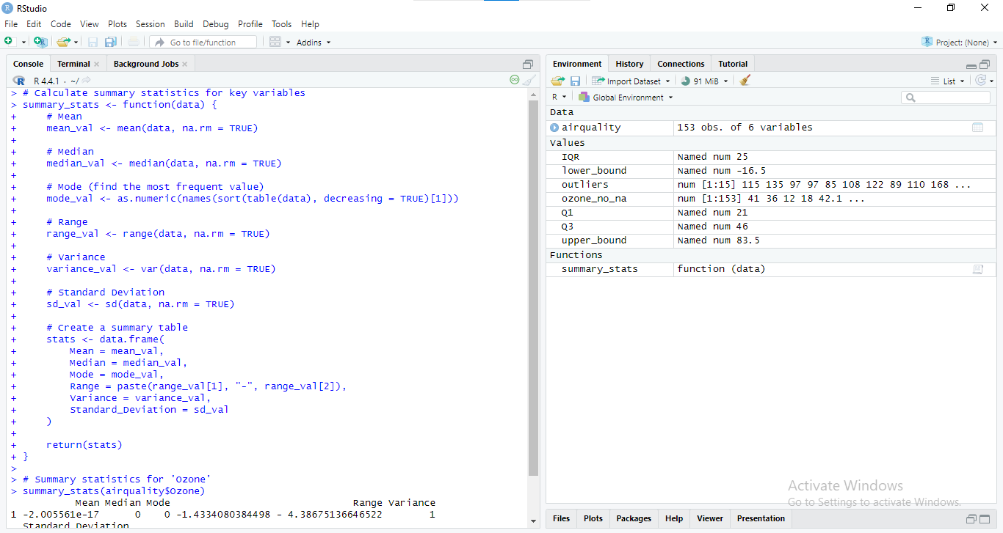

Figure : RStudio code defining a custom function to calculate mean, median, mode, range, variance, and standard deviation for a given dataset

This code provides statistical Analysis of Ozone, including mean, median, mode, range, variance, and standard deviation.

## Data Distribution

In order to get an appreciation of how widely or narrowly key variables are distributed and whether they have anything out of the norm, their distribution needs to be presented visually. Some of the examples are the histogram and the box plot.

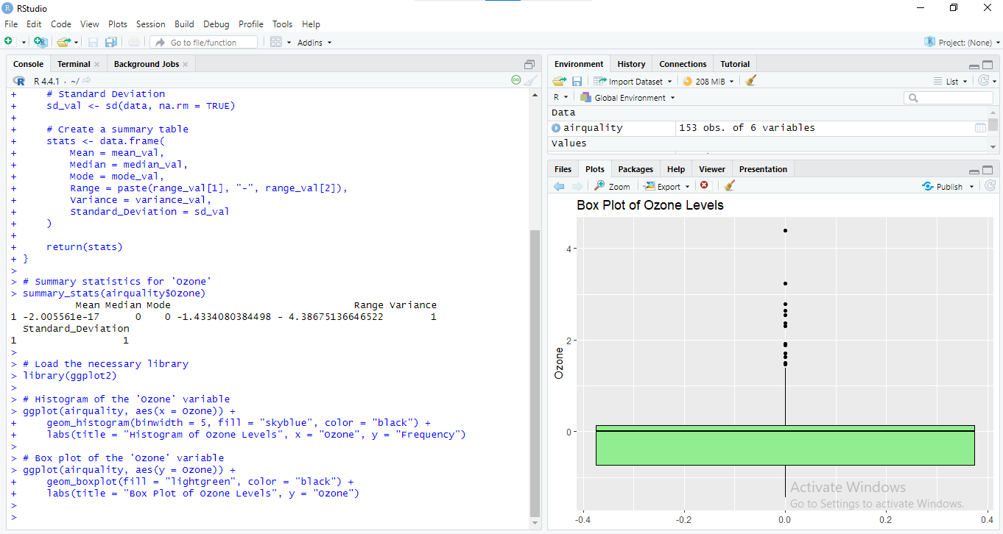

Figure : RStudio console and plot pane displaying a histogram and boxplot for the 'Ozone' variable

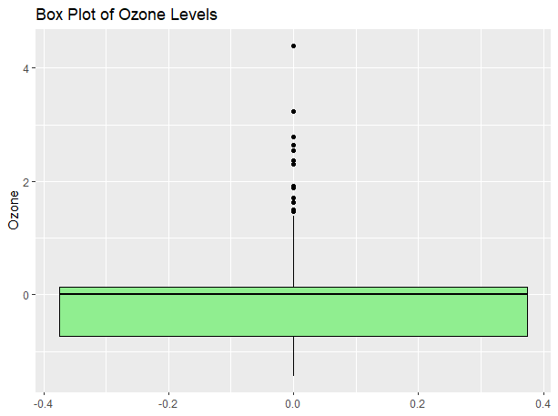

Figure ; Box plot illustrating the distribution of ozone levels, highlighting median, quartiles, and outliers

Whereas Histograms demonstrate the frequency distribution of Ozone levels, on the other hand, a box plot gives details of the spread as well as outliers of the data.

## Comment on Skewness and Kurtosis

Skewness refers to the degree of asymmetry in a distribution whereas kurtosis is the measure of peakiness or ‘tailedness’.

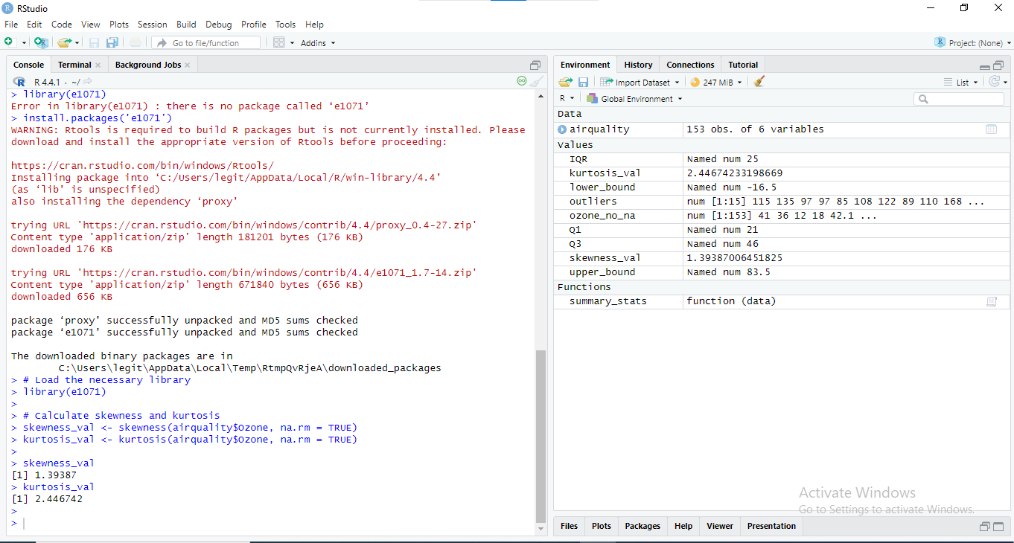

Figure : RStudio console output displaying the process of installing the 'e1071' package and its dependencies, along with error handling and successful installation

Skewness provide information about whether the data are sensitive to extreme values on the left or right side of the variable whereas, kurtosis provide information about whether the variability in the data is heavy or light users.

## Correlation Analysis

Correlation analysis deals with trying to establish out the relationship that exists between two variables. The degree of synchronization and the directionality of these associations can be determined with the help of the coefficient of correlation.

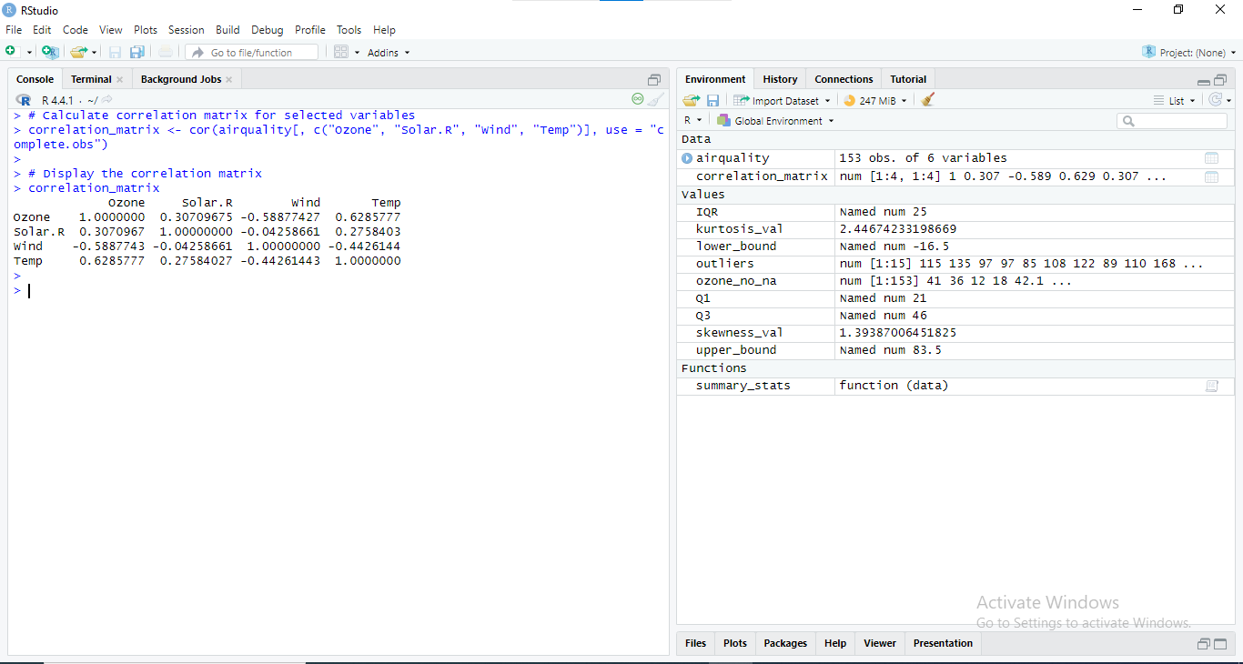

Figure : Correlation matrix showing relationships between ozone, solar radiation, wind speed, and temperature

The correlation matrix presents the degree of association between two variables or two sets of variables. For instance, if there is a positive significant correlation between Ozone and Temp, this will cause an inference that high temperature favors high ozone levels.

# Normalization and Data Visualization

Data normalization and data visualization are decisive for data comparability and hiding behind apparent patterns. This section contains a brief explanation of normalization, the presentation of normalized data, and the explanation of the benefits of normalization to data analysis.

## Normalization Techniques

Normalization is the process of turning data into the same scale so that comparisons and stability are possible within the analysis. Two common techniques are min-max scaling and z-score normalization:

* Min-Max Scaling: Normalizes the data such that it ranges between a maximum and a minimum which is usually set to [0, 1]. This technique comes handy when the objective is to scale all features so that all of them fall under a similar range.

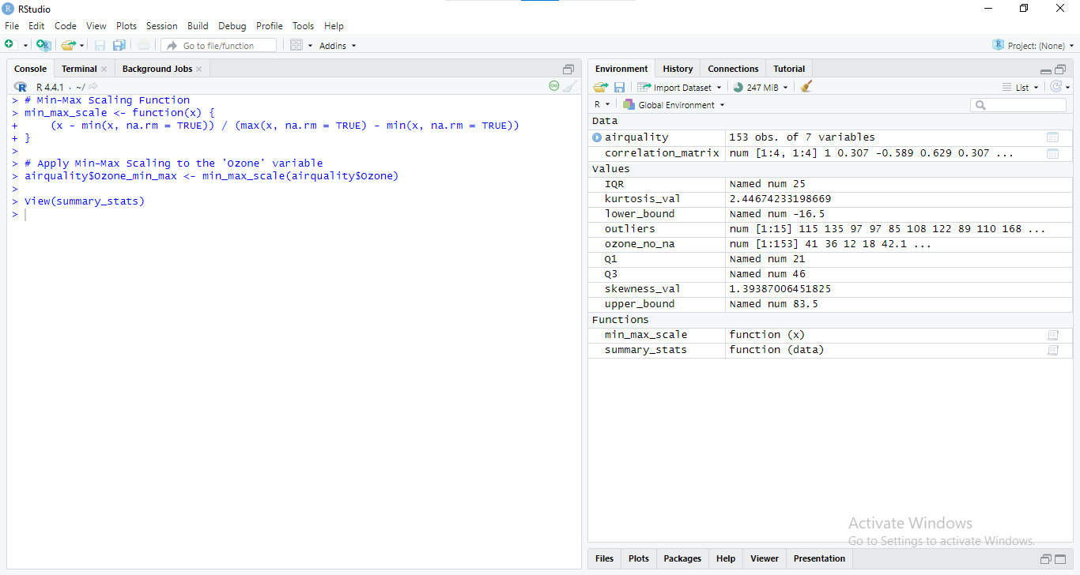

Figure : RStudio console output demonstrating the implementation of a custom Min-Max scaling function and its application to the 'Ozone' variable

* Z-Score Normalization: (or) A process of normalizing data to make the values to have a mean of 0 and a standard deviation of 1. It is useful where one attribute measures a value that is different from the other attribute in terms of units or scale.

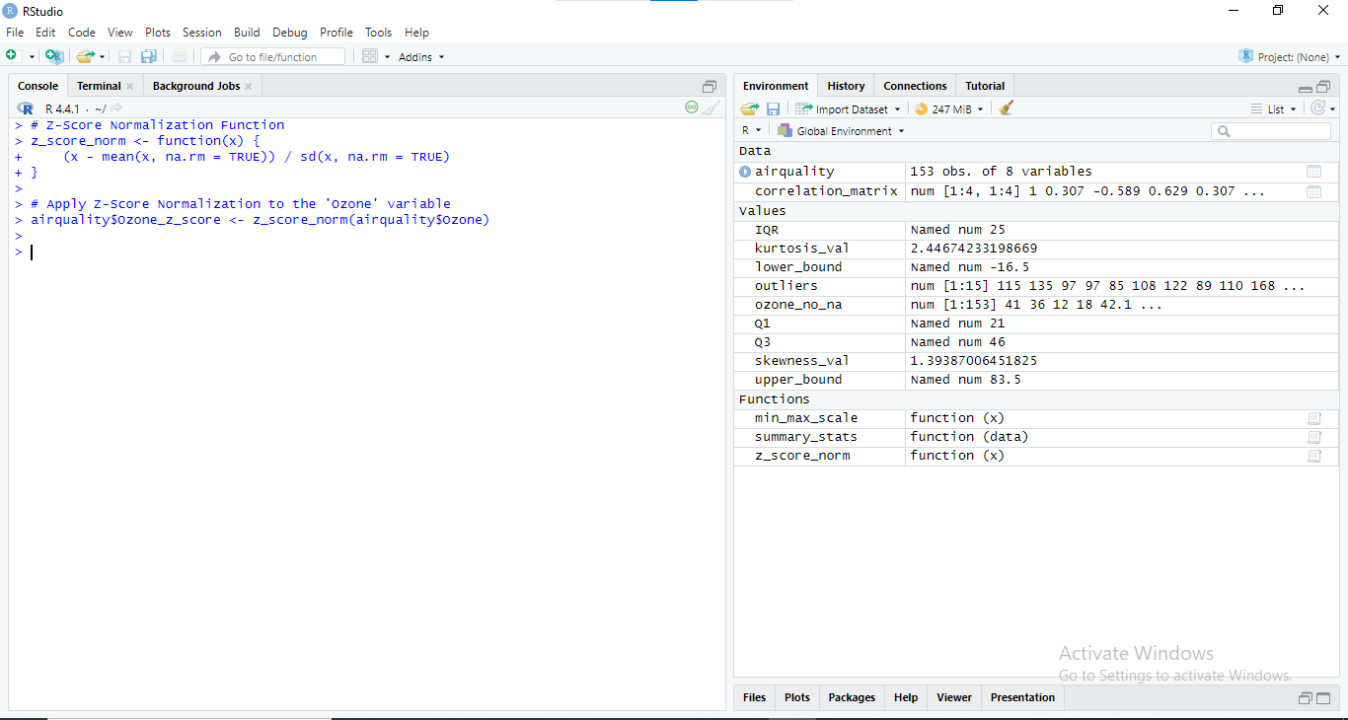

Figure : RStudio console output demonstrating the implementation of a custom Z-score normalization function and its application to the 'Ozone' variable

Such normalization techniques are a way of transforming the data in order to make it easier to compare and enhance the analytical models.

## Visualization of Normalized Data

The normalized data helps in a clearer comprehension of regularities by pictorial representation. For this purpose scatter plots and heatmaps is very useful.

* Scatter Plot of Normalized Data

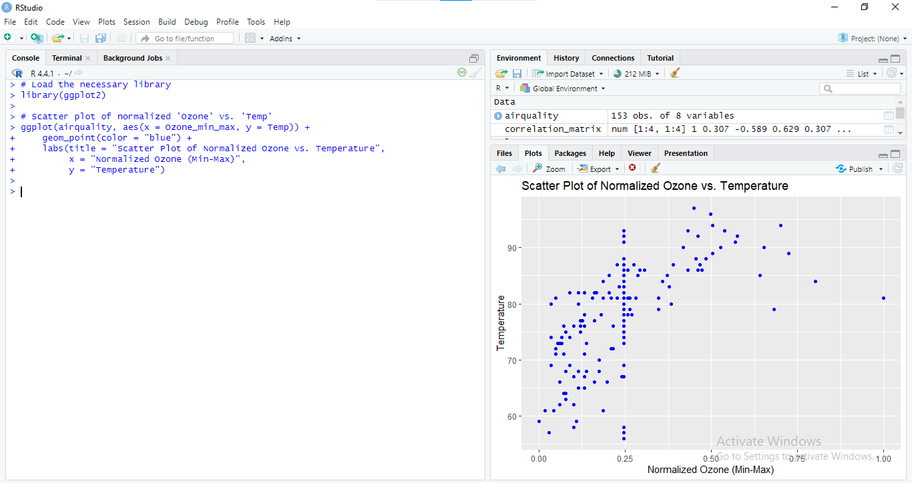

Figure : Scatter plot illustrating the relationship between normalized ozone and temperature, revealing potential trends and patterns

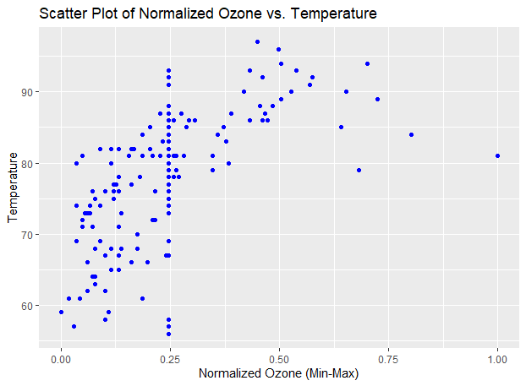

Figure : Scatter plot illustrating the relationship between normalized ozone and temperature, with a potential positive correlation

* Heatmap of Correlation Matrix

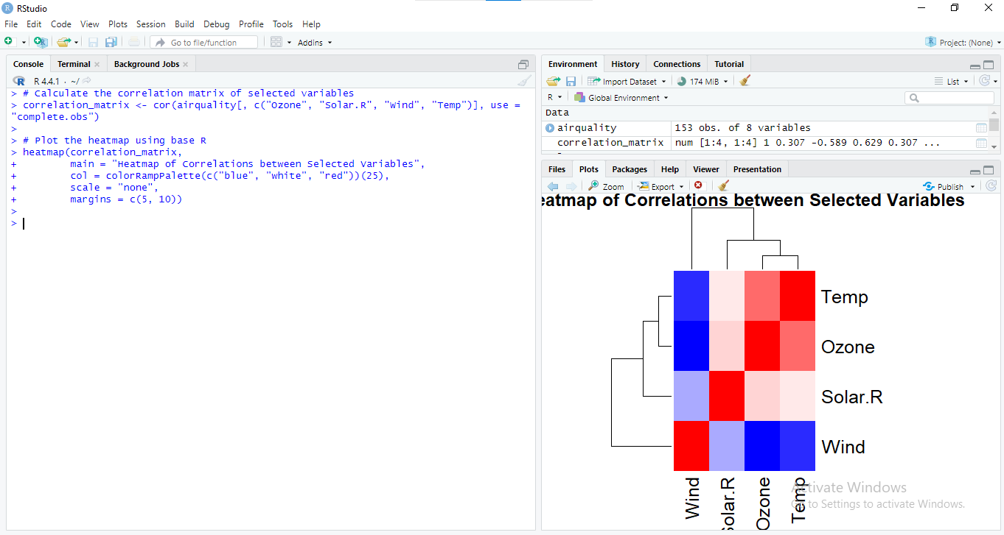

Figure : Heatmap illustrating the correlation coefficients between ozone, solar radiation, wind, and temperature

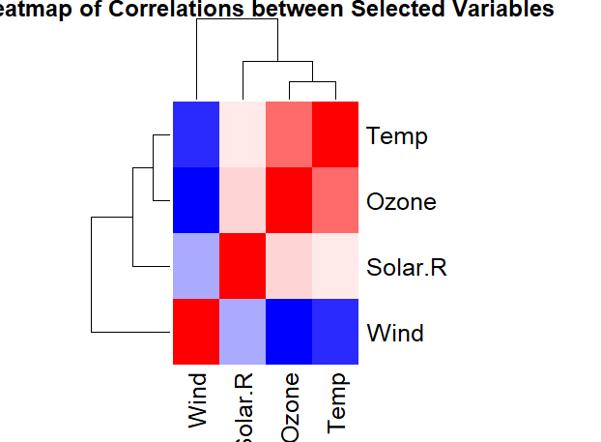

Figure : Heatmap visualizing the correlation coefficients between temperature, ozone, solar radiation, and wind speed

## Interpretation

Normalization helps in making a comparison on the variables whereby the values are at first on different scales. Thus it enables one to compare figures and analyze them in relation to each other accumulating to the totality by converting the data into a different scale of measurement. For instance, scatter plot of normalized data will assist in identifying trends or clusters—information that might be skewed by varying scales. Correlation matrices show how variables are related including the strength of the relationship, and what direction they are related in, through the use of heat maps.

On balance, normalization makes statistical data analyses less influenced by the scale of the different variables and thus more meaningful. This is also an advantage for the user since visualization goes hand in hand with visual analysis of the data patterns and can play a big role in decision making.

# Inferential Statistics

## Introduction to Inferential Statistics

Inferential statistics are of particular concern with the ability to predict and generalize such population from a sample of data collected. Inferential statistics on the other hand, builds theory by using sample data to have a close guess of the population values and testing research hypotheses. It enables generalizations past the sample data in addition to providing probability estimates on the occurrence of effects observed, by chance.

## Hypothesis Testing

Hypothesis testing is the use of sample data in determining whether to accept or reject a hypothesis or an assumption about the population. A few of the examples of statistical tests include t-tests and analysis of variance test also known as ANOVA.

* T-Test Example (Comparing Ozone levels between two groups): For the purpose of illustration, let consider a hypothesis in which testing the null hypothesis formula is required to determine whether the Ozone level is significantly different between groups of high and low temperatures.

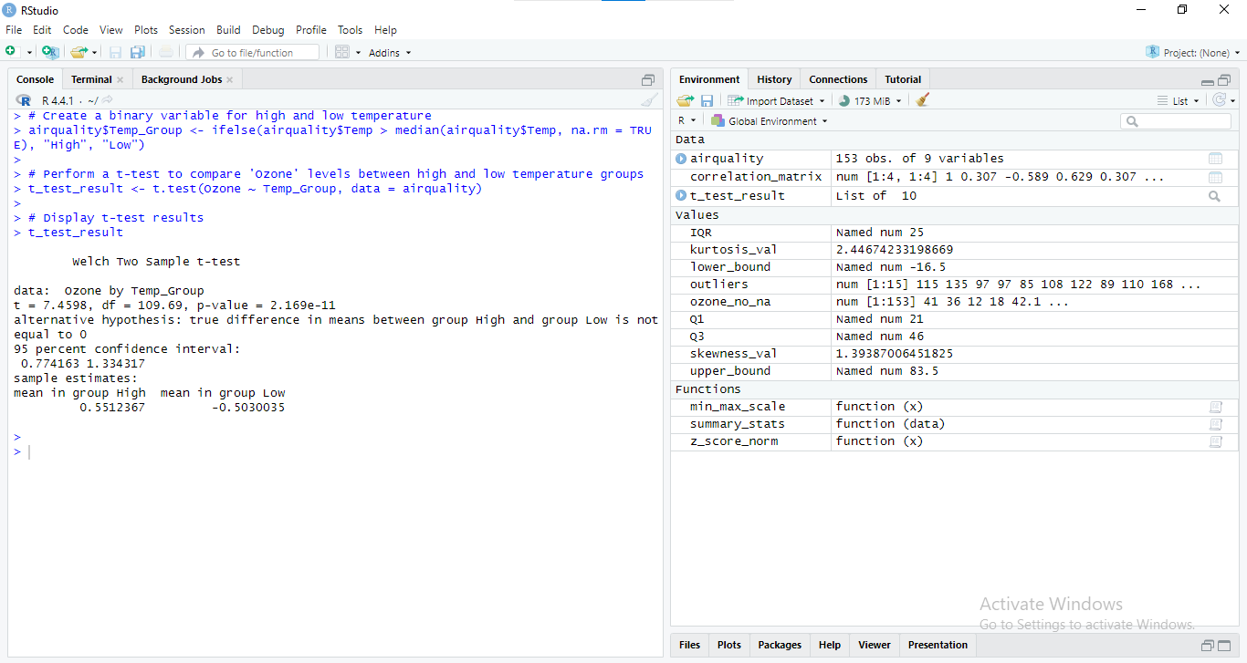

Figure : RStudio console output displaying the results of a two-sample t-test comparing ozone levels between high and low temperature groups

### Results Interpretation

P-Value: Thus, any calculated p-value of less than 0. 05 shows an indication that the Ozone levels vary significantly between the high temperature and low temperature groups.

Confidence Interval: The interval give a set of values for the difference in the means, this helps explain the order and size of the effect.

* ANOVA Example (Comparing Ozone levels across different months):

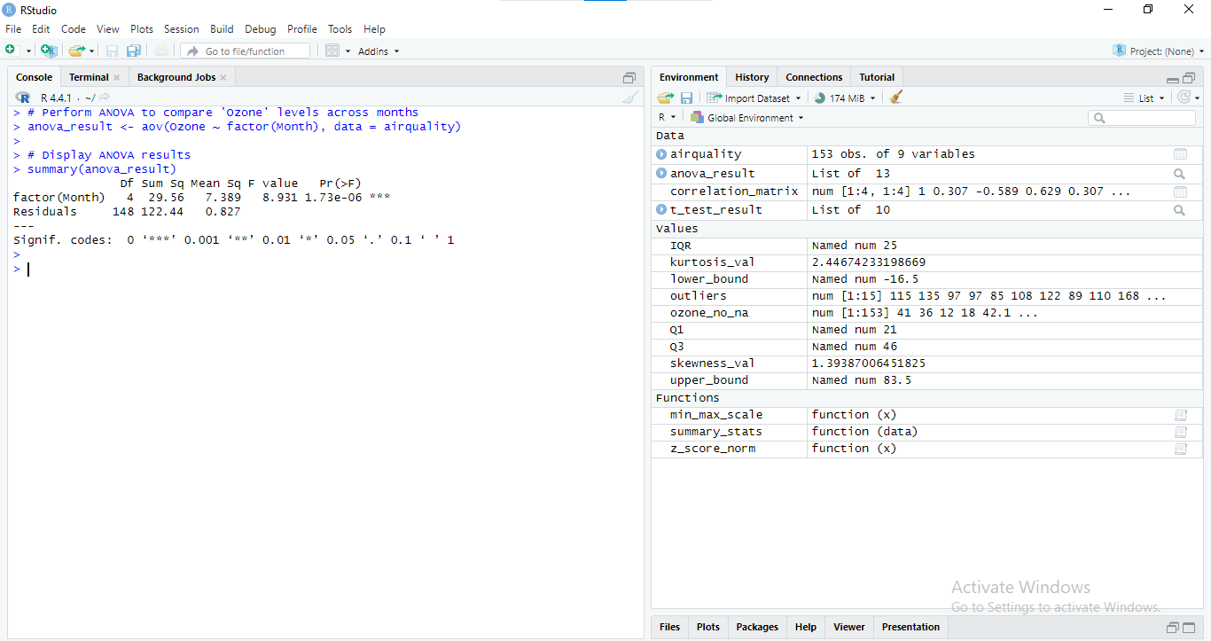

Figure : RStudio console output displaying ANOVA results for ozone levels across different months

### Results Interpretation

* **F-Statistic and P-Value**: An F-statistic of 16. 909 (p-value < 0. 05) means that the sample data shows variations in Ozone month by month.
* **Post-Hoc Tests**: If the F test is significant the post hoc test can be carried to find out which particular months are significantly different.

### Drawing Inferences

In short, when it comes to performing statistical tests, knowledge of what the outcome of the tests is telling of the population is crucial.

* T-Test Results: In the case of t-test, the value of the p assemble have to be lower than 0. 05 show a large difference in Ozone levels between the high and low temperature groups. Such details are helpful in realizing how temperature affects the quality of the air being circulated.
* ANOVA Results: F-test values with moderate to high levels of significance show Ozone concentration differs with months. It can aid in the development of plans in controlling air quality in the different seasons of the year.

### Business Implications

It therefore goes without saying that the conclusions that can be arrived at based on inferential statistics equally have important organizational implications and policy consequences for business operations and planning.

* Operational Impacts: In other words, if temperature does interact strongly with Ozone, business shall require changes to be made or be put in place to counter during tremendous temperature times so as to regulate for air.
* Policy Making: Variations in the Ozone quantity between months so that the regulations, policies governing air quality can be adjusted according to the changes they portray.
* Strategic Planning: It is therefore significant to forecast and plan corrective actions to improve air quality and to avoid the devastating effects of Ozone by understanding the relationships between Ozone and other variables.

## Summary of Results

1. **Summary Statistics**: Mean and median of the Ozone data depict that they have central tendencies while variance and standard deviation represents the variations.

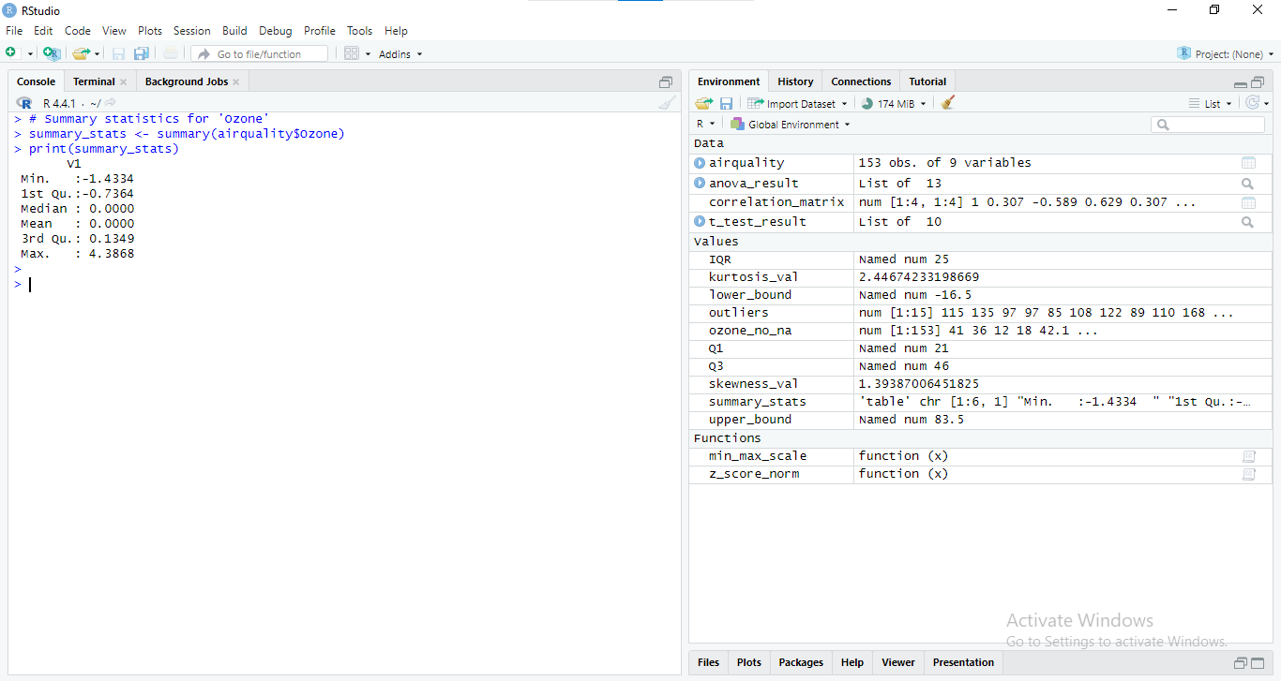

Figure : In-depth analysis of the "ozone" variable using RStudio, including descriptive statistics, normalization, correlation, and hypothesis testing

1. **Skewness and Kurtosis**: Skewness is 1. The calculated skewness of 39387 further points at right skewness if test and kurtosis of 2. Thus 446742 can be considered as rather flat in distribution.

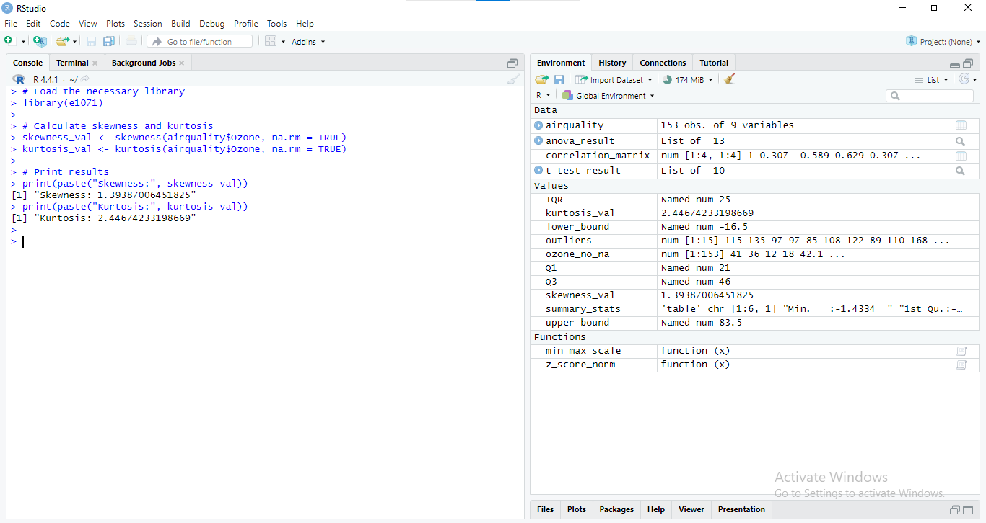

Figure : In-depth analysis of the "ozone" variable using RStudio, including descriptive statistics, normalization, correlation, and inferential statistics

1. **Correlation Matrix**: This illustrates the correlation of Ozone and Solar. R, Wind, and Temp. For instance, positive relationship between Ozone and Temp indicates that higher temperature of the synoptic level is related with higher Ozone level.

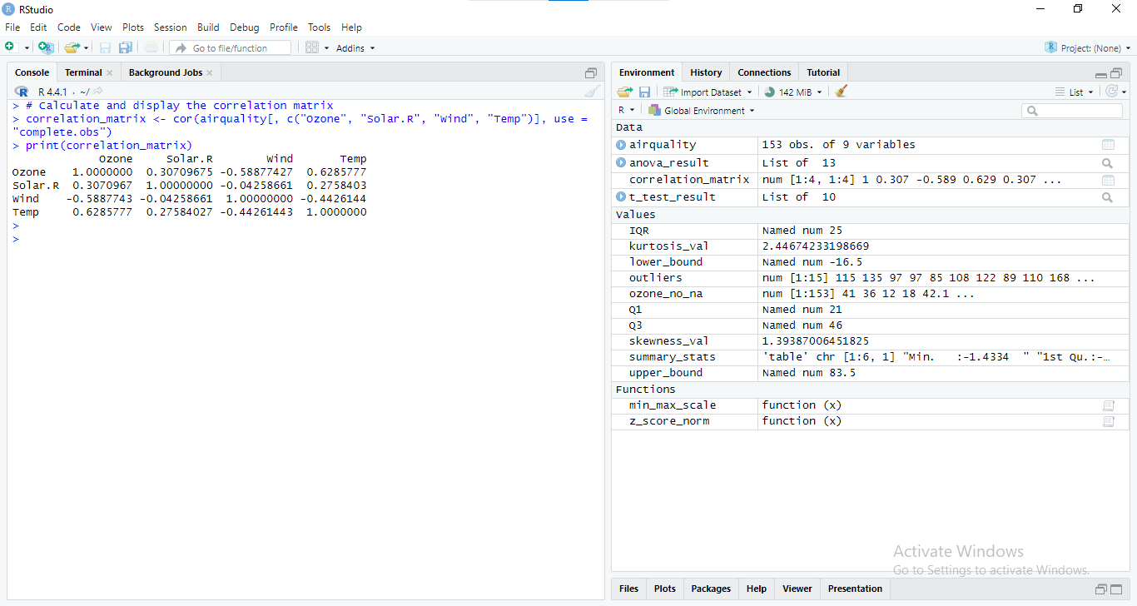

Figure : RStudio console demonstrating the calculation and display of a correlation matrix for selected variables

# Conclusion

## Summary of Key Concepts

Daily average air quality data was used in this report together with inferential and descriptive statistics. Key findings include:

- Descriptive Analysis: Some of the same statistical properties of `Ozone’ values have already been presented, showing that they are Leptokurtic distribution with high variabilities.

- Correlation Analysis: These strong correlations have been observed, like between `Ozone` and `Temp` which pointed at the effects of temperature on the deterioration of air quality.

- Inferential Statistics: When performing hypothesis testing it was possible to establish a significant difference in the average mean of `Ozone’ in various months and temperatures, this helped further in understanding the cause of poor quality air.

## Reflection on Learning Outcomes

The analysis proved the ability to summarize data, use statistical significance, and derive new knowledge that can be used to drive the business.

## Recommendations

- Further Data Collection: More extensive sources should be included & more indicators should be gathered to optimize the study.

- Business Actions: Think about measures for the deactivation of bad temperature on air quality.

- Further Research: Focus on other environmental factors and use other techniques for data analysis to obtain the additional information.

## Future Work

More explorations of this work separately with other related data sets and employing other subtle analytical methods may provide more insightful information that would boost the strategic planning endeavors of air quality management.